지유
Thanksgiving & Chuseok (강사용)
(추석과 미국 추수감사절 비교하기)
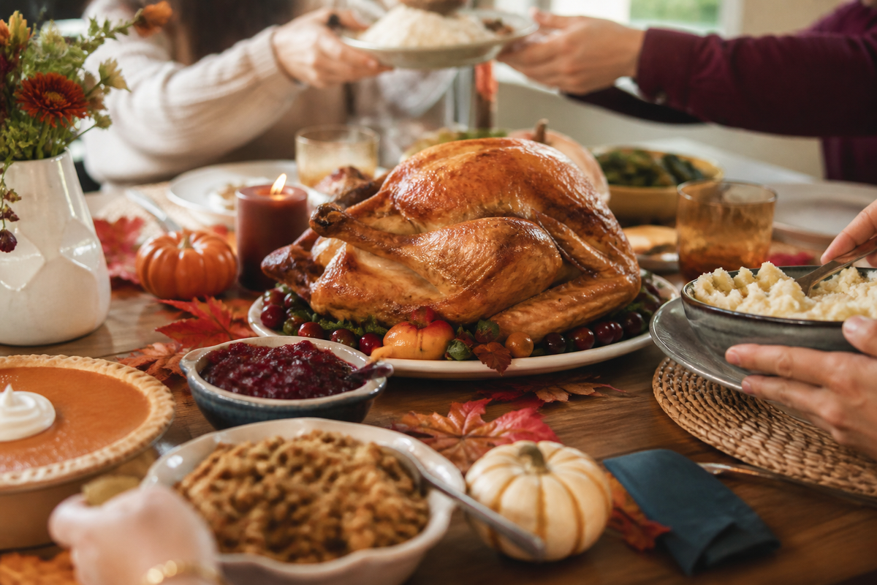
🙋 Warm-Up
질문을 읽고 자유롭게 대답해 보세요.
Q1. Did you have a good Chuseok? What did you do?
→ Yes, I did. I went to my grandmother's house and met my cousins.
Q2. What did you eat on Chuseok?
→ I ate songpyeon, jeon, and galbi. I ate too much!
Q3. Do you know Thanksgiving? What do you know about it?
→ It is an American holiday. People eat turkey with their family.
📖 Vocabulary (단어)
오늘 나오는 단어예요. 소리 내어 읽어 보세요.
English | Korean | Example sentence
harvest | 수확 | Fall is harvest season.
holiday | 명절, 휴일 | Chuseok is a big holiday in Korea.
celebrate | 기념하다, 축하하다 | We celebrate Chuseok in September or October.
get together | 모이다 | My family gets together on Chuseok.
feast | 잔치, 큰 식사 | We had a big feast at my grandmother's house.
ancestor | 조상 | We visit our ancestors' graves.
full moon | 보름달 | We saw the full moon on Chuseok.
rice cake | 떡 | Songpyeon is a half-moon rice cake.
turkey | 칠면조 | Americans eat turkey on Thanksgiving.
thankful | 감사하는 | I'm thankful for my family.
traditional | 전통적인 | Ssireum is a traditional Korean game.

📖 Reading 1 — Thanksgiving
소리 내어 읽어 보세요.
Thanksgiving is a holiday in the United States and Canada.
Americans celebrate it on the fourth Thursday in November.
A long time ago, the Pilgrims came to America from England. Their first winter was very hard.
Native Americans taught them how to grow corn and how to fish and hunt.
In 1621, they had a good harvest, so they had a big feast for three days.
Today, families get together and eat turkey, mashed potatoes, and pumpkin pie.
It is a day to say “thank you” for family, food, and health.
📖 Reading 2 — Chuseok
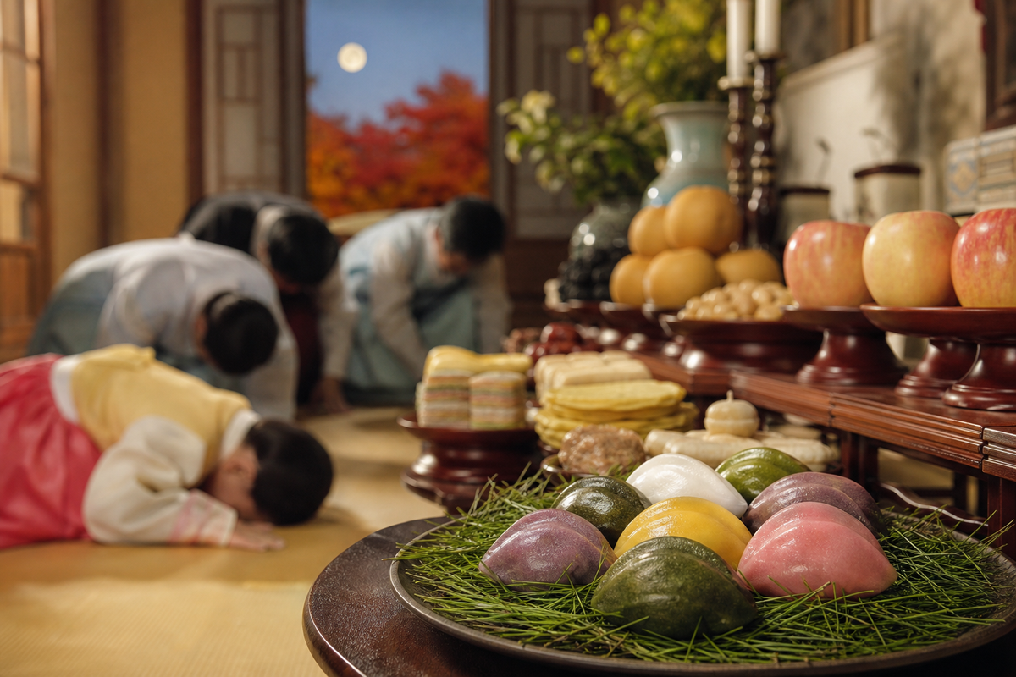
Chuseok is a Korean harvest holiday.
It is on the 15th day of the eighth month of the lunar calendar. On this day, the moon is full.
Families get together and eat songpyeon, half-moon rice cakes.
Many families visit their ancestors' graves and clean them.
People also play traditional games like ssireum, Korean wrestling.
Chuseok is like Korean Thanksgiving.
✅ True or False?
맞으면 T, 틀리면 F를 쓰세요.
1. Thanksgiving is in October in the United States. ( F (November) )
2. The Pilgrims came from England. ( T )
3. Native Americans helped the Pilgrims. ( T )
4. People eat songpyeon on Thanksgiving. ( F (on Chuseok) )
5. Chuseok is on a full moon day. ( T )
6. Ssireum is a Korean food. ( F (It is a game.) )
💬 Ask & Answer
지문을 보고 답해 보세요.
Q1. When is Thanksgiving in the United States?
→ It is on the fourth Thursday in November.
Q2. Who taught the Pilgrims how to grow corn?
→ Native Americans taught them.
Q3. What do Americans eat on Thanksgiving?
→ They eat turkey, mashed potatoes, and pumpkin pie.
Q4. What do Koreans eat on Chuseok?
→ They eat songpyeon.
Q5. What do families do on Chuseok?
→ They get together, eat songpyeon, and visit their ancestors' graves.
📊 Compare! (비교하기)
표를 채워 보세요.
 | Thanksgiving | Chuseok
Country | the United States, Canada | Korea
When | the fourth Thursday in November | the 15th day of the 8th lunar month
Food | turkey, mashed potatoes, pumpkin pie | songpyeon, jeon, fruit
What people do | get together, eat a big meal, say thank you | get together, visit ancestors' graves, play ssireum

🗣 Everyday Expressions
오늘의 표현이에요. 예문을 읽고 따라 말해 보세요.
Expression | Korean | Example sentence
get together | 모이다 | Let's get together on Chuseok!
I'm thankful for ~ | ~에 감사해요 | I'm thankful for my friends.
have a big meal | 푸짐하게 먹다 | We had a big meal at my grandma's house.
I'm stuffed! | 배불러 죽겠어! | I ate three songpyeon. I'm stuffed!
Happy Chuseok! / Happy Thanksgiving! | 즐거운 추석 / 추수감사절 보내! | Happy Chuseok, teacher!

💬 Let's Talk!
위의 표현을 사용해서 대답해 보세요.
Q1. What is your favorite Chuseok food?
→ My favorite Chuseok food is songpyeon. I like the sweet ones.
Q2. What are you thankful for?
→ I'm thankful for my family and my friends.
Q3. Which holiday do you like more, Chuseok or Christmas? Why?
→ I like Christmas more because I get presents. But I like Chuseok food.
Q4. If you go to America, do you want to try turkey and pumpkin pie?
→ Yes! I want to try turkey. I don't know pumpkin pie, but I want to try it.
✍️ Homework
이번 추석에 한 일을 영어로 3문장 써 오세요. (get together, I'm thankful for, I'm stuffed 사용하기)
1. ________________________________________________________________
2. ________________________________________________________________
3. ________________________________________________________________
+ 오늘 배운 expressions 암기해 주세요~

